**LIBRARY SYSTEM FLOW CHART**

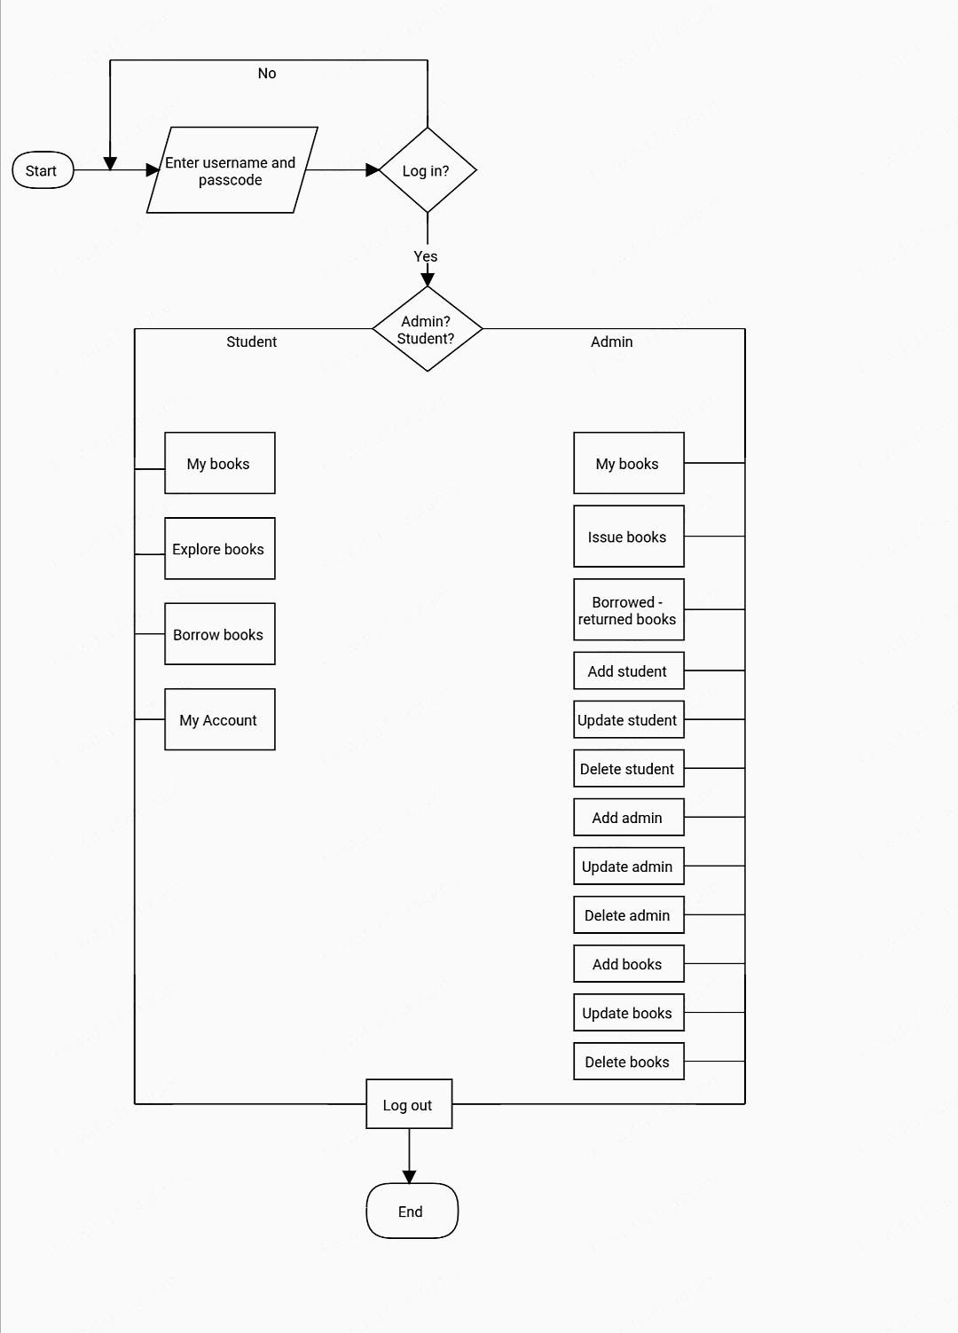

**Flow Chart of the Library System**: It shows that there’s only one login page. When someone tries to login, the system will evaluate the user if it is admin or student. If the system will direct the admin in the DashBoard. In the DashBoard Page admin can see and access every single pages of the system. If student is the one who logged in, the system will direct the student to the “My Book Page’’ where student can see the list of books that student have been borrowed and returned in the last 5 days. There is also a sidebar where user can see the “Explore books’’ and “My Account”.

**CRUD OF ADMIN**

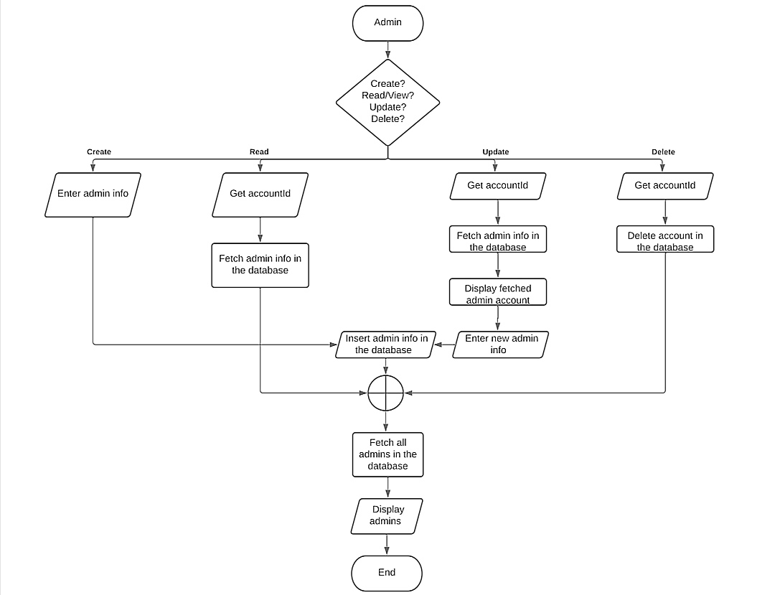

**Work Flow CRUD of ADMIN:** This flow shows the “admin page” where the admin can “create”, “read/view”, “update”, and “delete” the information of all the admins in the system. After the admin performs a particular action, the system will redirect the admin to the “admin page” that shows the updated list of admins.

**CRUD of STUDENT**

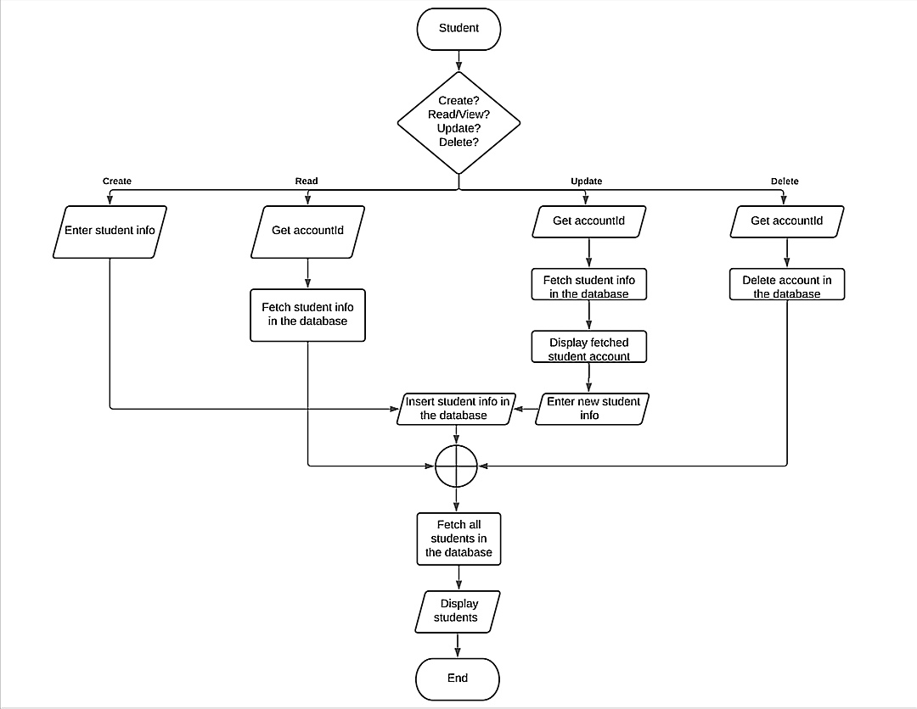

**Work Flow CRUD of STUDENT:** This flow shows the “student page” where the admin can “create”, “read/view”, “update”, and “delete” the information of all the students in the system. After the admin performs a particular action, the system will redirect the admin to the “student page” that shows the updated list of admins.

**CRUD of BOOK**

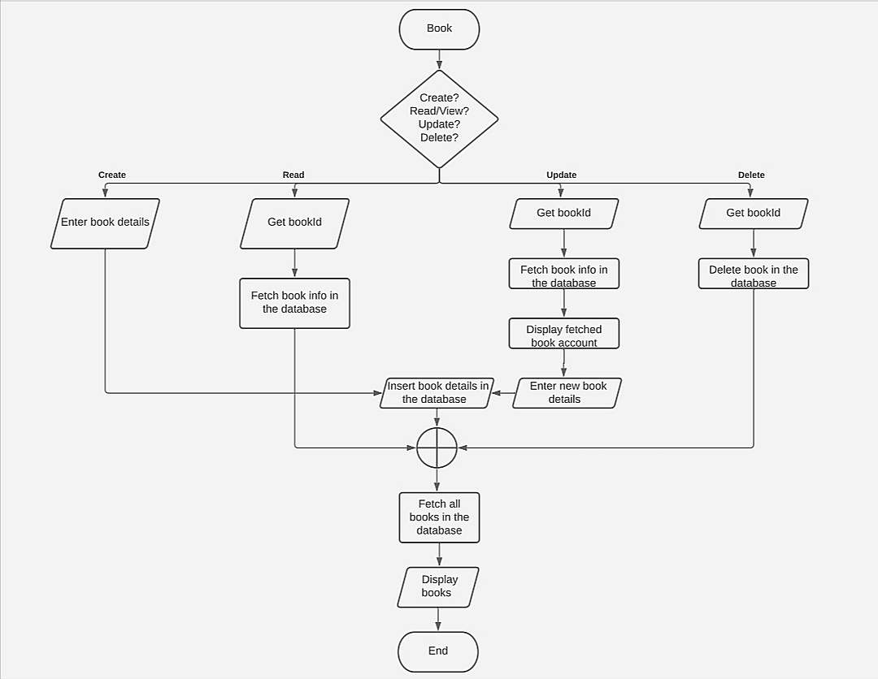

**Work Flow CRUD of BOOK:** This flow shows the “book page” where the admin can “create”, “read/view”, “update”, and “delete” the information of all the books in the system. After the admin performs a particular action, the system will redirect the admin to the “book page” that shows the updated list of admins.